
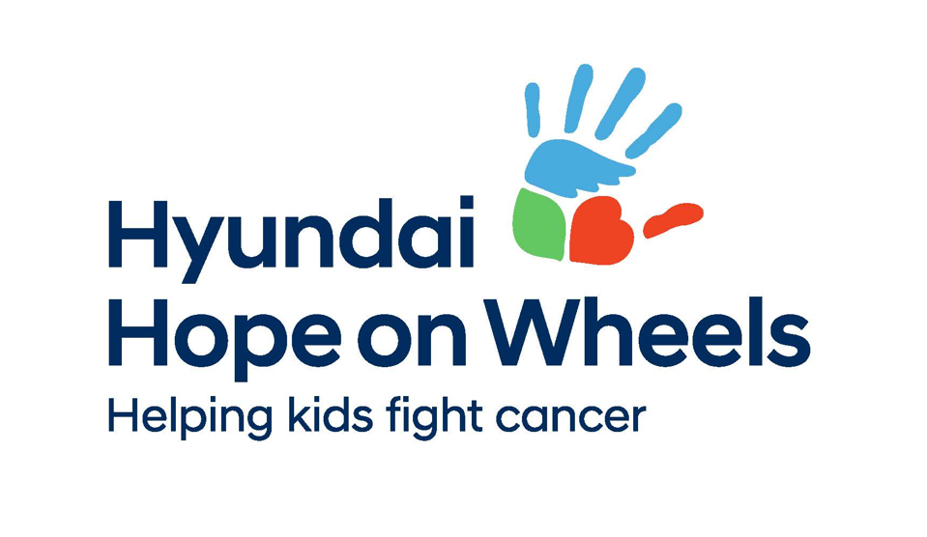

Hyundai Hope on Wheels Canada
& C¹⁷ Council
2026 Clinical Trials Support & Infrastructure Grant Application Form

The Hyundai Hope on Wheels Canada Grants are adjudicated
and administered by the C¹⁷ Council, through the C¹⁷ Research Network.

DEADLINES:

Email Registration: June 22nd, 2026

Grant Submission: July 13th, 2026

A. ADMINISTRATIVE DETAILS

Project Title
Full title
Abbreviated title

Principal Investigator (one only)
Last name: |  | LAST NAME
First name: |  | First name and initial (if applicable)
Position:
Institute/affiliation:
Department:
Mailing address:
(room #, street, building)
City: |  |  | Province:
Postal code: |  |  | Email:
Telephone:

Co-Investigators (optional)
Co-Investigator(s) if applicable
Last name: | LAST NAME
First name: | First name and initial (if applicable)
Position:
Institute/affiliation:
Department:
Mailing address:
(room #, street, building)
City: |  |  | Province:
Postal code: |  |  | Email:
Telephone:
Co-Investigator(s) if applicable
Last name: |  | LAST NAME
First name: |  | First name and initial (if applicable)
Position:
Institute/affiliation:
Department:
Mailing address:
(room #, street, building)
City: |  |  | Province:
Postal code: |  |  | Email:
Telephone: |  |  | Fax:

Institutional Affiliation
Applicants must have an affiliation with one or more of Canada’s pediatric oncology programs.
Check the Institute(s) this project is affiliated with:

Applicants must e an affiliation with one or more of Canada’s pediatric oncology programs.

Applicants must have an affiliation with one or more of Canada’s pediatric oncology programs.
☐ Alberta Children’s Hospital, Calgary, AB
☐ BC Children’s Hospital, Vancouver BC
☐ CancerCare Manitoba, Winnipeg MB
☐ Children’s Hospital of Eastern Ontario (CHEO), Ottawa, ON
☐ Centre Hospitalier de l'Université Laval (CHUQ), Quebec City, QC
☐ IWK Health Centre, Halifax, NS
☐ Janeway Children’s Health and Rehabilitation Centre, St. John’s, NF
☐ Jim Pattison Children’s Hospital, Saskatoon SK
☐ Kingston Health Sciences Centre, Kingston, ON
☐ Children’s Hospital, London Health Sciences Centre, London, ON
☐ McMaster Children’s Hospital, Hamilton, ON
☐ McGill University Health Centre - Montreal Children's Hospital, Montreal, QC
☐ Centre Hospitalier Universitaire de Sherbrooke (CHUS), Sherbrooke, QC
☐ Centre Hospitalier Universitaire Sainte-Justine, (CHU Ste Justine), Montreal, QC
☐ The Hospital for Sick Children (SickKids), Toronto, ON
☐ Stollery Children’s Hospital, Edmonton, AB
☐ Other:
☐ Other:
☐ Other:

5. Signatures

 | Principal Investigator:
 | Name:
 | Signature: |  | Date:

 | Pediatric Division Chief (C¹⁷ Director) or Division/Department Chair:
 | Name:
 | Signature: |  | Date:

 | Authorized Finance Official at the Institution:
 | Name:
 | Signature: |  | Date:

B. PROJECT DETAILS

Lay Summary (max 500 words)
Describe the proposed project, how it will improve clinical research in Canada and the impact it will have. The Lay Summary will be used for promotional purposes for successful applications.

Academic Summary (max 300 words)
Describe the objectives, proposed activities, infrastructure improvements, impact and other relevant operational details. The Summary will be used for external reporting purposes for successful applications.

Project Proposal (max 2 pages)
Describe the proposed project and explain how the activities will enable, strengthen, expand, operationalize, or improve pediatric oncology clinical trials. Tables and figures are included in the page limit; references may be separate.

Clinical Trial Relevance and Impact (max 300 words)
Describe the clinical trial(s) impacted by the proposed infrastructure or activities, including the anticipated benefit to pediatric oncology clinical trial capacity, how the project will improve patient access, efficiency, coordination, or trial activation, the expected measurable outcomes, and the potential for sustainability or future impact.

Multi-Site Collaboration (max 200 words)
Describe the extent to which the proposed project supports collaboration across Canadian institutions.

- Personnel and Team Roles
Describe all personnel supported by the grant and their roles within the project.
Personnel | Role

C. MILESTONES & DELIVERABLES

Milestones and Deliverables (max 1 page)
Define and clearly describe milestones and deliverables for the successful implementation of your proposed project. For milestones, specify dates and include a timeline. Ensure that deliverables are measurable, tangible and/or documentable output that are tied to a specific delivery date on the timelines. Details to be used in the award agreement for successful applications.

Feasibility and Risk Mitigation (max 250 words)
Describe anticipated risks, barriers, ethical, operational or feasibility concerns with the potential to impact the project timeline and/or completion; include mitigation strategies, timeline feasibility and dependencies

Regulatory and Ethics Status
Describe the status of any applicable?
Health Canada CTA | Status, if applicable:
Research Ethics | Status, if applicable:
Institutional approvals | Status, if applicable:
Data Sharing Agreements | Status, if applicable:
Contracts or Site activation activities | Status, if applicable:
Not applicable | ☐
D. FUNDING & BUDGET INFORMATION

Funding Information Summary

Total Amount Requested (up to $40,000): $

Project duration: 12 months ☐ 24 months ☐

Are the proposed aims feasible with only the HHOW & C¹⁷ funding? Yes ☐ No ☐

Have you applied for other funds for this same proposal? Yes ☐ No ☐
If yes, where:
% overlap*:
Decision date:

Have you secured other funds for all/part the research described in this proposal? Yes ☐ No ☐
Funder:
Funding period:
% overlap*:

* Note that successful overlapping research costs will not be funded. Please attach a copy of the project aims and the budget summary/justification of other successful funding awards after this page. If additional/other grant funding is received after receipt of this award, please contact C¹⁷ for information regarding reallocation of funds.

Budget Request and Justification
It is important to consult the HHOW_C17 Council Clinical Trial Impact Grant Application Instructions and Award Guide (ver 11May26) for more information, including ineligible budget items.
A separate budget summary in Excel format is required. The budget shall:
- Tie the budget to milestone-linked activities
- Include detailed justification for all requested costs
- Reflect expenditures by category and by year
- For staff expenditures, identify time contribution (e.g., FTE)

E. OTHER INFORMATION

Knowledge Mobilization and Impact (max 250 words)
Describe how project outputs, tools, and/or systems will be shared and implemented.

Patient Engagement (max 400 words)
Applicants are encouraged to incorporate patient engagement and the perspectives of patients with lived experience (PWLE) where appropriate.

F. SUPPORTING DOCUMENTS

Curriculum Vitae
Provide an abbreviated CV for the Principal Investigator and Co-Investigators. CVs are limited to 5 pages per individual.

Letters of Support
Letters of support are encouraged for collaborating institutions, shared infrastructure, participating clinical trial groups, data-sharing or operational support.

Appendixes
Appendixes (optional) should be limited and directly relevant to the application. Reviewers are not obligated to review appendices.

